

PROGRAM OVERVIEW

Date | Time | Film | Venue
Tue 9 Feb | 7:30pm | Human Face of Big Data/Who Cares** | Federation Square
Wed 10 Feb | 7:30pm | Who Cares?** | Federation Square
Thur 11 Feb | 8:30pm | Small is Beautiful** | New Joneses @ City Square
Thur 18 Feb | 7:00pm | Opening Night: Catching the Sun** | Cinema Nova
Fri 19 Feb | 6:30pm | Ice and Sky** | Cinema Nova
Fri 19 Feb | 8:45pm | Two Raging Grannies* | Cinema Nova
Sat 20 Feb | 12:30pm | Hip Hop-eration*** | Cinema Nova
Sat 20 Feb | 2:30pm | Polyfaces* | Cinema Nova
Tue 23 Feb | 6:30pm | Breath of Life* | Cinema Nova
Tue 23 Feb | 8:45pm | Haida Gwaii: On the Edge of the World* | Cinema Nova
Wed 24 Feb | 6:30pm | Poverty, Inc.* | Cinema Nova
Wed 24 Feb | 8:45pm | Requiem For the American Dream* | Cinema Nova
Thur 25 Feb | 6:30pm | Plant This Movie* | Cinema Nova
Thur 25 Feb | 8:45pm | 10 Billion: What’s On Your Plate* | Cinema Nova
Fri 26 Feb | 6:30pm | Overburden* | Cinema Nova
Fri 26 Feb | 8:30pm | The Price We Pay* | Cinema Nova
Sat 27 Feb | 12:30pm | The Rainforests Are Under Threat** | Cinema Nova
Sat 27 Feb | 2:30pm | Return of The River** | Cinema Nova
Mon 29 Feb | 6:30pm | That StartUp Show | Lab14 Carlton Connect
Tue 1 March | 6:30pm | The Infinite Happiness* | Cinema Nova
Tue 1 March | 8:30pm | Strange and Familiar* | Cinema Nova
Wed 2 March | 6:30pm | Code: Debugging the Gender Gap* | Cinema Nova
Wed 2 March | 8:45pm | Capital C: The Crowdfunding Revolution* | Cinema Nova
Thur 3 March | 7:00pm | Closing night: Anthropocene* | Cinema Nova

CLASSIFICATION
*This film has been exempt from classification and is restricted to people over 15 years. People under 15 must be accompanied by an adult.
**This film has been exempt from classification and has no age restrictions.
*** Rated M

WELCOME

This year the Transitions Film Festival turns five. When we first started in 2012—almost half a decade ago—the myths, ravings and comedic spoofs of popular culture were telling us that the world was going
to fall into an apocalyptic dystopia, or be symbolically reborn.

We are still here, and the challenges we face have gained in gravity and urgency. The problems are not new, or any less daunting.
What is new is the rate and scale that good ideas are making their way into mainstream consciousness, the increasingly insightful questions that are being asked, and the accelerated uptake of new ideas and innovations across the globe.
Over the past few months we have witnessed civilians participating in some of the largest street marches in history, wealthy elites donating their fortunes, politicians creating a historically significant climate agreement in Paris, and the beginning of Australia’s transition from an extractive economy to an ideas and innovations economy.
The films in this year’s program paint a portrait of a world that is waking up and rising to the challenges of global civilization at an unprecedented speed. They show that we don’t need revolutionary inventions or breakthrough technologies to create a better world. If we ask good questions and recalibrate our vision in the right way,
we can create remarkable change.
We can transition from coal to renewables and avert the worst threats of climate change, we can shift from a
global economy that is systemically designed to implode, to a model that works for the majority of people. We can build houses and cities that make us happy and grow food that nourishes and vitalizes us. We can create impact with businesses that profit from purpose, and solve the problem of global poverty with innovative models of empowerment and enterprise.
We don’t just need a boom of new ideas, we need the right ideas to self-fertilize and cross-pollinate. In a world of finite time and infinite distractions, we must know how to focus, what to care about and what to share.
The films in this year’s program are the seeds to a new world.
Let the #IDEASBLOOM

Daniel Simons
National Director


Full program, trailers and bookings online
transitionsfilmfestival.com

More info & bookings at transitionsfilmfestival.com 1

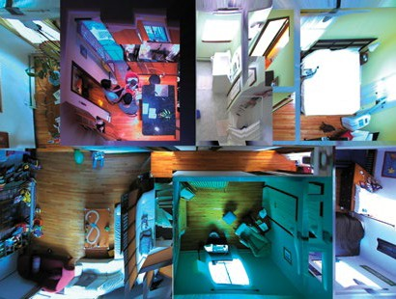PRE FESTIVAL SCREENINGS AND SIDE EVENTS

HUMAN FACE OF BIG DATA & WHO CARES

On the Big Screen at Federation Square
One Big Screen, two huge films. Human Face of Big Data and Who Cares show the exciting new
worlds that are being created through mind-boggling innovative technologies and the rise of the global Social Enterprise movement.

TUE 9 FEB & WED 10 FEB

SMALL IS BEAUTIFUL

The New Joneses—City Square
Join Transitions Film Festival and The New Joneses at City Square for a free outdoor screening of tiny house film Small is Beautiful. Bring a blanket and
a pillow and lean back as the Projector Bike beams a heartwarming Melbourne-made flick onto the side of The New Joneses pre-fab house—right
in the heart of the city.
B.Y.O snacks, drinks, nibbles
(waste-free/recyclable packaging please).

THU 11 FEB, 8:30PM

THAT STARTUP SHOW

Carlton Connect, University of Melbourne
Join CEO & Startup Show Co Founder Anna Reeves and a panel of some of Australia’s leading innovation experts for an exclusive screening of hit online TV show That Startup Show with some exclusive behind the scenes content. Followed by an intelligent discussion about “going boom” with creative and purposeful companies.

MON 29 FEB, 6:30PM

2 Transitions Film Festival 9 February – 3 March 2016

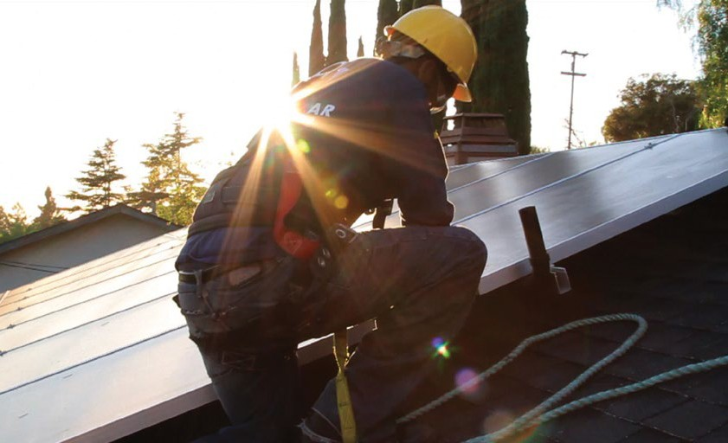CINEMA NOVA PROGRAM 18 FEB – 3 MAR 2016

OPENING NIGHT
CATCHING THE SUN
2015 | 74 min | USA Directed by Shalini Kantayya

Followed by discussion with the Filmmaker (USA)

Presented by Bank Australia

Australian Premiere
Solar energy, green jobs—the unstoppable future, where everyone wins.
Catching the Sun is a celebration of the green energy revolution that is exploding across the planet. Featuring Obama’s green jobs advisor, Van Jones, as well as the workers of the new green world, Catching the Sun highlights the power of the solar revolution to solve the world’s most pressing environmental and social problems.

THU 18 FEB, 7PM
The screening will be followed by a Q and A with the film maker.
Shalini Kantayya finished in the top 10 out of 12,000 filmmakers on Fox’s ON THE LOT, a show by Steven Spielberg in search of Hollywood’s next great director. She is a Sundance Fellow, a TED Fellow, and was a finalist for the ABC Disney | DGA Directing Fellowship.

Followed by Opening Night party at the Nova Bar

More info & bookings at slf.org.au 3

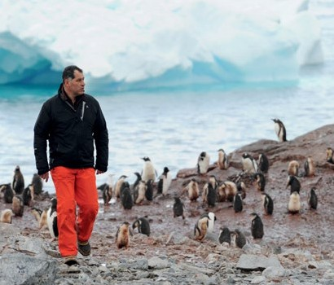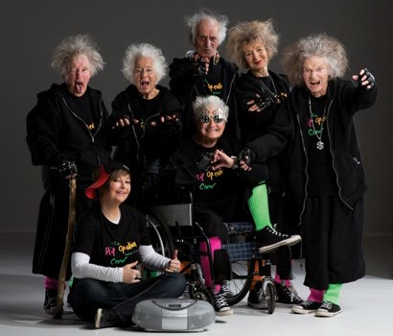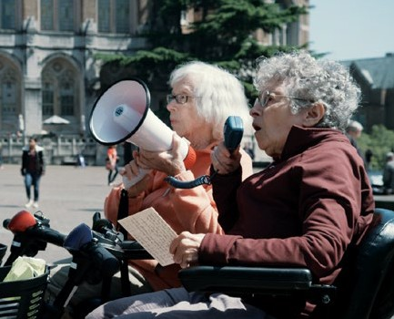ICE AND SKY
2015 | 89 min | France
Directed by Luc Jacquet

Followed by panel discussion
Presented by the EU Centre
on Shared Complex Challenges
Follow Antarctic explorer and scientist Claude Lorius and film maker Luc Jacquet (March of the Penguins) on a beautiful journey back to the historic moment where we first found evidence of a human footprint in climate change.

FRI 19 FEB, 6:30PM

TWO RAGING GRANNIES
2013 | 78 min | Norway
Directed by Håvard Bustnes

Australian Premiere
Two Raging Grannies is a hilarious road movie following two gutsy old ladies on their mobility scooters as they embark on a quest to seek answers to the burning question: How do we get out of
our economic mess?

FRI 19 FEB, 8:45PM

HIP HOP-ERATION
2014 | 93 min | New Zealand
Directed by Bryn Evans
Hip Hop-eration follows a troupe of courageous,
yet cheeky, senior citizens on an extraordinary quest to perform at the World Hip Hop Championships in Las Vegas. Led by their exuberant and ‘I must have been mad’, manager, Billie Jordan they learn to throw away their wheelchairs and walking sticks and push their bodies and artificial joints to the absolute limits of old age.

SAT 20 FEB, 12:30PM

4 Transitions Film Festival 9 February – 3 March 2016

POLYFACES
2015 | 92 min | Australia
by Lisa Heenan and Isaebella Doherty Followed by Q & A with the Filmmakers Presented by Dumbo Feather Australian Premiere
A portrait of the world’s most innovative farmer and the regenerative farming practices that have the power to transform the global food system for the better.

SAT 20 FEB, 2:30PM
CINEMA NOVA PROGRAM 18 FEB – 3 MAR 2016

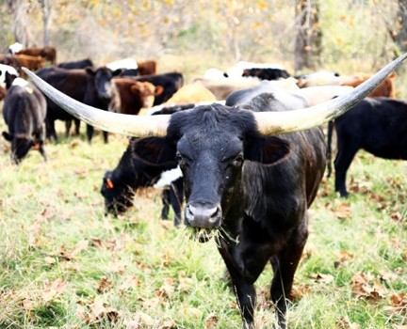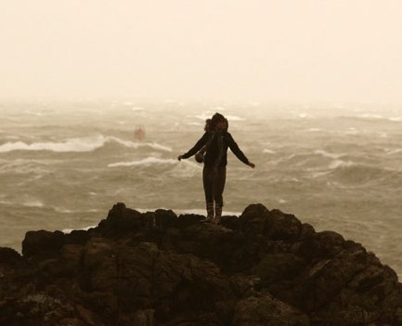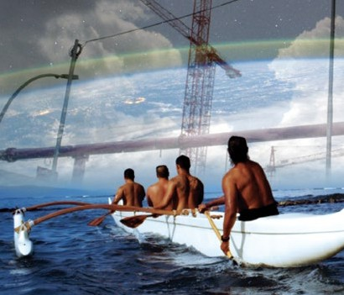

BREATH OF LIFE
2015 | 82 min | USA
Directed by Susan Kucera

Followed by panel discussion
Presented by Melbourne Sustainable Society Institute
Australian Premiere
This stunning documentary captures the insights of world-famous evolutionary scientists, everyday farmers and indigenous wisdom keepers into why we have not reacted with the energy and urgency required by the existential challenges we face.

TUE 23 FEB, 6:30PM

HAIDA GWAII: ON THE EDGE OF THE WORLD
2015 | 74 min | CANADA
Directed by Charles Wilkinson

Australian Premiere
Winner of Best Canadian Feature at HotDocs, Haida Gwaii spotlights the potential of a balanced life that respects the beauty, power and abundance of nature.

TUE 23 FEB, 8:45PM

More info & bookings at transitionsfilmfestival.com 5

CINEMA NOVA PROGRAM 18 FEB – 3 MAR 2016

POVERTY, INC.
2014 | 94 min | USA
Directed by Michael Matheson Miller
Presented by Lush
Australian Premiere
Poverty Inc. is a challenging exploration and critique of the global aid industry and the complexities of ending poverty.
It takes a critical look at the ‘poverty industry’, where foreign aid, often given with the best of intentions, frequently exacerbates the very problems that it is trying to solve.
Will the challenges of global poverty be solved through charity and donations, or is empowerment and social enterprise the answer?
Drawing from over 200 interviews, filmed in 20 countries,
Poverty Inc. unearths the uncomfortable challenges
of well intended, but uneducated giving, and suggests a new way of thinking is needed to overcome global, systemic challenges for the betterment of all.

WED 24 FEB, 6:30PM
REQUIEM FOR THE AMERICAN DREAM
2015 | 73 min | USA
Directed by Jared P. Scott | Kelly Nyks | Peter Hutchison
Noam Chomsky, one of the most important intellectuals alive, unpacks the principles that have brought us to the crossroads of historically unprecedented inequality.
The film traces half a century of policies designed to favour the most wealthy at the expense of the majority.
Requiem for the American Dream outlines a detailed map of how elites extract and maintain dominance.
It is required viewing for all who maintain hope in a shared stake in the future.

WED 24 FEB, 8:45PM

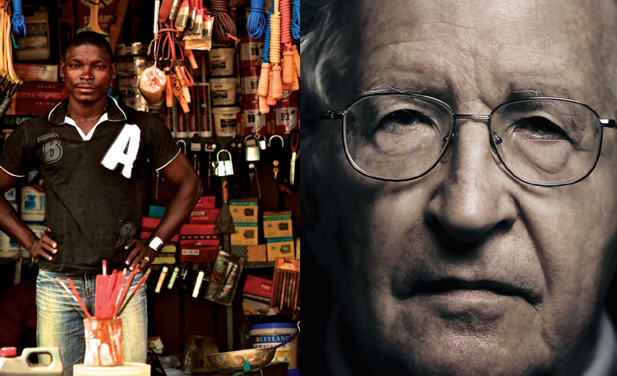

6 Transitions Film Festival 9 February – 3 March 2016

READ
INTELLIGENT NEWS

The Saturday Paper is a remedy for the wane in quality journalism, offering the weekend’s best in news, culture and analysis.
Enjoy long-form, in-depth accounts of the most important topics affecting Australia, written by the best writers in the country.

Available in bookshops, newsagencies and for home delivery.

VISIT THESATURDAYPAPER.COM.AU OR CALL 1800 077 514

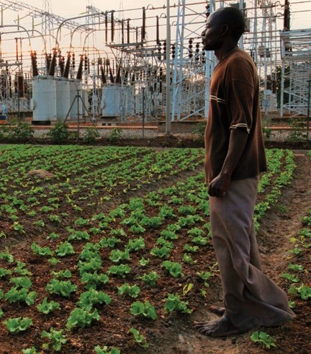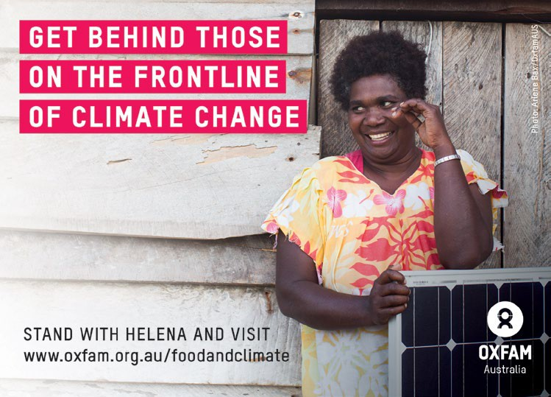

PLANT THIS MOVIE
2014 | 83 min | USA
Directed by Karney Hatch Followed by panel discussion Presented by Oxfam Australian Premiere
Narrated by Daryl Hannah, Plant This Movie explores the zeitgeist of urban farming around the world.
From the incredible story of Havana, Cuba, to cities as diverse as Shanghai, Calcutta, Addis Ababa,
London, and Lima, the rise of urban agriculture is an unstoppable force.
From vacant lots, to rooftops, to front yards, the place for food in our cities is changing, and Plant This Movie shows why.

THU 25 FEB, 6:30PM

8 Transitions Film Festival 9 February – 3 March 2016

10 BILLION—WHAT’S ON YOUR PLATE
2015 | 102 min | Germany
Directed by Valentin Thurn Presented by Oxfam Australian Premiere
CINEMA NOVA PROGRAM 18 FEB – 3 MAR 2016

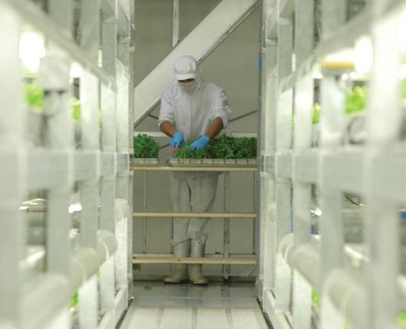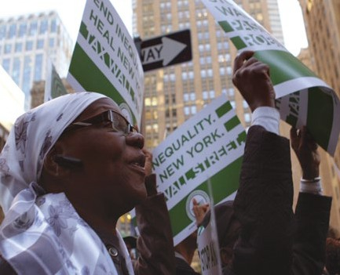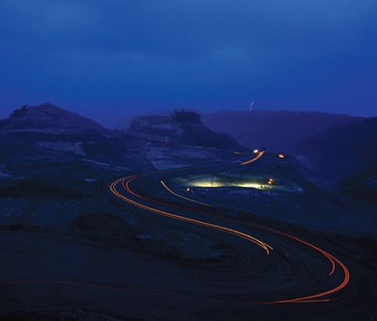Director, best selling author, and self-proclaimed ‘food fighter’ Valentin Thurn (Taste the Waste) travels the world asking the question: ‘How are we going to feed ourselves?’ – the answers will shock and inspire.

THU 25 FEB, 8:45PM

OVERBURDEN
2015 | 65 min | USA
Directed by Chad A. Stevens Followed by panel discussion Australian Premiere
The international coal industry is in a “terminal decline”, leaving communities facing an uncertain and dire future. Overburden is the first film of its kind to document the end of the age of coal and celebrate the heroes who are standing up to rebuild their fractured communities.

FRI 26 FEB, 6:30PM

THE PRICE WE PAY
2014 | 90 min | Canada
Directed by Harold Crookd

Australian Premiere
The Price We Pay is an engrossing and enraging investigation into the dire present-day reality of
big-business tax avoidance. Tax justice campaigners and former finance insiders speak frankly about what needs to be rectified if the West is to have
a sustainable future.

FRI 26 FEB, 8:30PM

More info & bookings at transitionsfilmfestival.com 9

THE RAINFORESTS ARE UNDER THREAT 2015
97 MIN | USA
Directed by Jerome Dolbert

Australian Premiere
Situated in the heart of the Andes mountains and bordered by five countries and the Pacific Ocean, Peru is the third largest country in South America and boasts the second largest area of tropical rainforest in Latin America.
These rainforests host over 10 percent of the world’s flora and fauna, placing Peru among the top 10 “megadiverse” countries on the planet.
The Rainforests are Under Threat is a new multi-award winning documentary underscoring the threats facing this ecological treasure-trove and the people who are fighting to protect it.

SAT 27 FEB, 12:30PM
RETURN OF THE RIVER
2014 | 72 min | USA
Directed by Jessica Plumb and John Gussman Presented by Great Forest National Park Australian Premiere
Return of the River follows an inspirational group
of strong-minded environmentalists as they attempt the unimaginable: to change the public opinions
of a nation to bring down a dam.
In a David and Goliath battle of environment
vs industry, Return of the River shows how, when nature is appropriately valued and respected, anything is possible.

SAT 27 FEB, 2:30PM

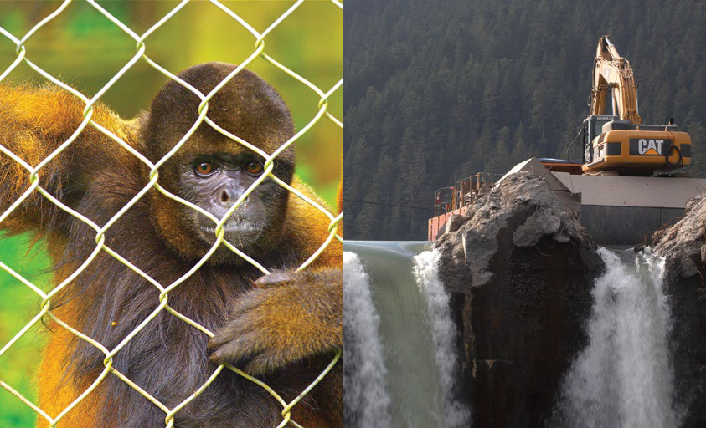

10 Transitions Film Festival 9 February – 3 March 2016

CINEMA NOVA PROGRAM 18 FEB – 3 MAR 2016

THE INFINITE HAPPINESS
2015 | 85 min | France/Denmark
Directed by Ila Beka and Louise Lemoine
An all-access pass to one of the most fascinating buildings built in the last decade and the power
that design has to influence the way we live our lives.
Copenhagen’s “8 House,” an ultramodern loop of apartments created by architect Bjarke Ingels, reinvents the concept of “home.”
Its 500 residents can traverse all nine floors by bike while their kids attend kindergarten on the ground floor.
This exuberant film profiles the (mostly) happy residents and offers a hopeful, inspired picture of communal living by design.

TUE 1 MAR, 6:30PM
STRANGE AND FAMILIAR + SHORTS
2015 | 54 min | Canada
Directed by Katherine Knight and Marcia Connolly
Presented by Green Magazine
Australian Premiere
On Fogo Island, a Maritime community has been facing devastation since the collapse of cod fishing.
Native architect Todd Saunders and social entrepreneur Zita Cobbs have come up with a radical solution: a stunningly original hotel, which is intended to act as a catalyst for the community.
Visually stunning and gorgeously photographed over the Island’s seven seasons, the film is a flowing, visual narrative celebrating design and community.

TUE 1 MAR, 8:30PM

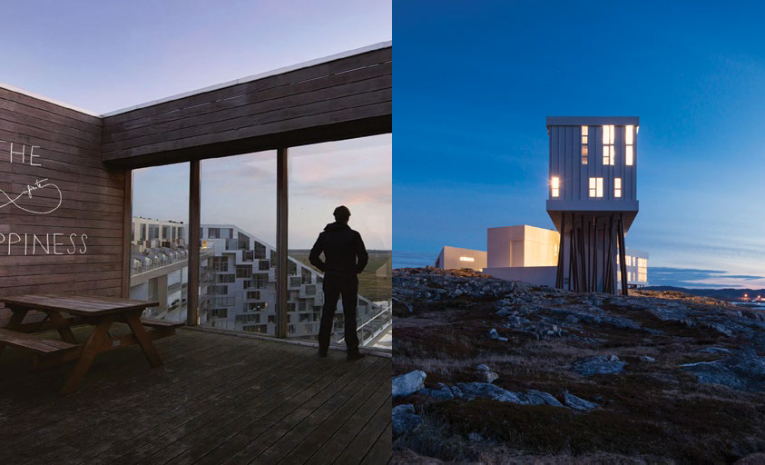

More info & bookings at transitionsfilmfestival.com 11

CODE: DEBUGGING THE GENDER GAP
2015 | 78 min | USA
Directed by Robin Hauser Reynolds

Followed by panel discussion
Presented by Clearpoint Counsel and BlueChilli
Australian Premiere
Code examines the reasons why more girls are not seeking opportunities in computer science and aims
to inspire change in mindsets, in the educational system, in startup culture and in the way women see themselves in the field of coding. Expert voices from the worlds of tech, psychology, science, and education are intercut with inspiring stories of women who are engaged in the fight to challenge complacency in the tech industry and have their voices heard.

WED 2 MAR, 6:30PM
CAPITAL C: THE CROWDFUNDING REVOLUTION
2014 | 87 min | Germany
Directed by Directed by Jorg Kundinger & Timon Birkhofer

Introduced by Tom Dawkins (CEO) StartSomeGood
Presented by StartSomeGood
Australian Premiere
In just a few years, crowdfunding has empowered a whole new generation of artists to create things in a way that has never been done before.
Capital C is a fun and heartwarming feature length documentary dedicated to crowdfunding, focusing on the hopes and dreams, as well as the fears and pitfalls, of independent creators in the wake of the digital age.

WED 2 MAR, 8:45PM



12 Transitions Film Festival 9 February – 3 March 2016

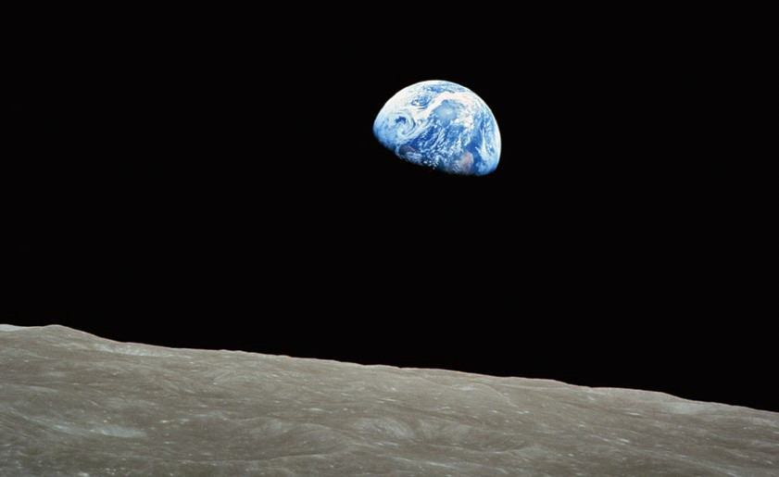CINEMA NOVA PROGRAM 18 FEB – 3 MAR 2016

CLOSING NIGHT
ANTHROPOCENE
2015 | 95 min | UK
Directed by Steve Bradshaw
Followed by panel discussion featuring Matt Wicking (The General Assembly), Alex Kelly (Impact Producer, This Changes Everything) and Dr Angus Hervey (Political Economist, Future Crunch)
Australian Premiere
What will we do now that we know we are the new weather-makers?
Directed by the Emmy-Award winning Steve Bradshaw, Anthropocene is a deeply fascinating guided tour from the big bang to the present day. It is a journey through the history of our world, the evolution of the term ‘anthropocene’, and the dilemmas we now face knowing the immense power we have to change the face and composition of the entire planet.

THU 3 MAR, 7:00PM

Followed by closing night party at the Cinema Nova Bar

More info & bookings at transitionsfilmfestival.com 13

FESTIVAL INFORMATION
The Transitions Film Festival is a visionary festival dedicated to showcasing inspirational documentaries about the social and technological innovations, revolutionary ideas
and trail-blazing changemakers that are leading the way to a better world.

TICKETS
Opening and Closing Night Tickets
$35 Full
$30 Concession

Regular Sessions
$19.50 Full
$15.50 Students and Seniors, Bike Helmet Discount
$12.50 Pensioners, Health Care Card Holders and Children
Bookings transitionsfilmfestival.com/ melbourne-program-2016

DISCOUNTS
Purchase tickets to 10 or more separate sessions and pay
$12.50 per film. Only available for bookings in person via Cinema Nova Box Office and offer excludes opening and closing night sessions. All 10 sessions must be selected at time of booking. Switching sessions is not permitted, no exchanges or refunds for sessions missed.

HELMET DISCOUNT
Show your bike helmet at the Cinema Nova
Box Office for concession price tickets at $15.50 each. One redemption, per person, per session

WIN TICKETS TO OPENING NIGHT!

Visit transitionsfilmfestival.com/win
To enter use CODE: SUNCATCHER

VENUES

Cinema Nova
380 Lygon St, Carlton

City Square (New Joneses)
67 Swanston St, Melbourne

Federation Square
Cnr Flinders and Swanston St, Melbourne

Carlton Connect
LAB–14, 700 Swanston St, Carlton

FESTIVAL TEAM

Festival Founder
Tim Parish

National Director
Daniel Simons

General Manager
Angie Muccillo

Publicity
Erin Jameson PR

Booklet Cover
Imaginary Foundation—Study imaginaryfoundation.com

Booklet Design
Aer Design

CONNECT WITH US

Website
transitionsfilmfestival.com

Facebook
facebook.com/TransitionsFF

Twitter
twitter.com/TransitionsFest

Email
info@transitionsfilmfestival.com

#TFFEST16

JOIN THE CONVERSATION
This year we’re sharing visions of a better world.
If you have a great idea, image, video, article or invention to share, post it on social media using the hashtag #IDEASBLOOM

14 Transitions Film Festival 9 February – 3 March 2016

PARTNERS

More info & bookings at transitionsfilmfestival.com 15

Principal Partners



Major Media Partners

Major Partners



Supporting Partners


T H A T LIVE
FROM
MELBOURNE
S T A R T U P S H O W



Media Partners



